Project Development Phase

**Delivery of Sprint 2**

|  |  |
| --- | --- |
| ***DATE*** | 05 NOVEMBER 2022 |
| ***TEAM ID*** | PNT2022TMID45387 |
| ***PROJECT NAME*** | GAS LEAKAGE DETECTION AND ALERTING system for industries |
| ***MAXIMUM MARKS*** | 20 MARKS |

Step1: Install node red and open node red in command prompt

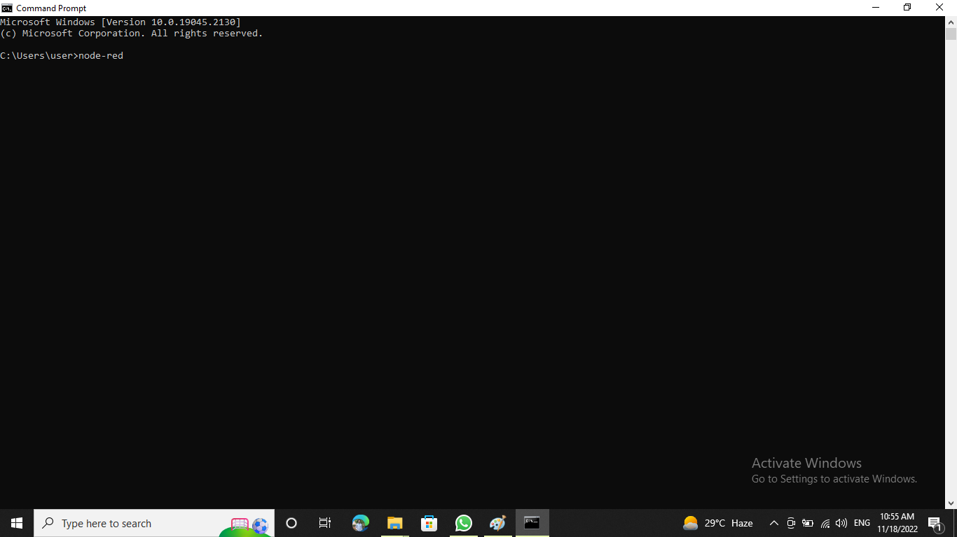

Step 2: Select IBM IoT input in node

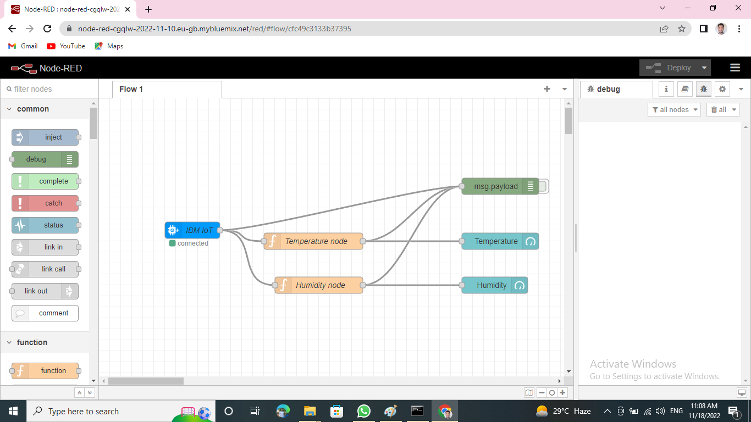

Step 3: In IBM Watson platform, go to apps

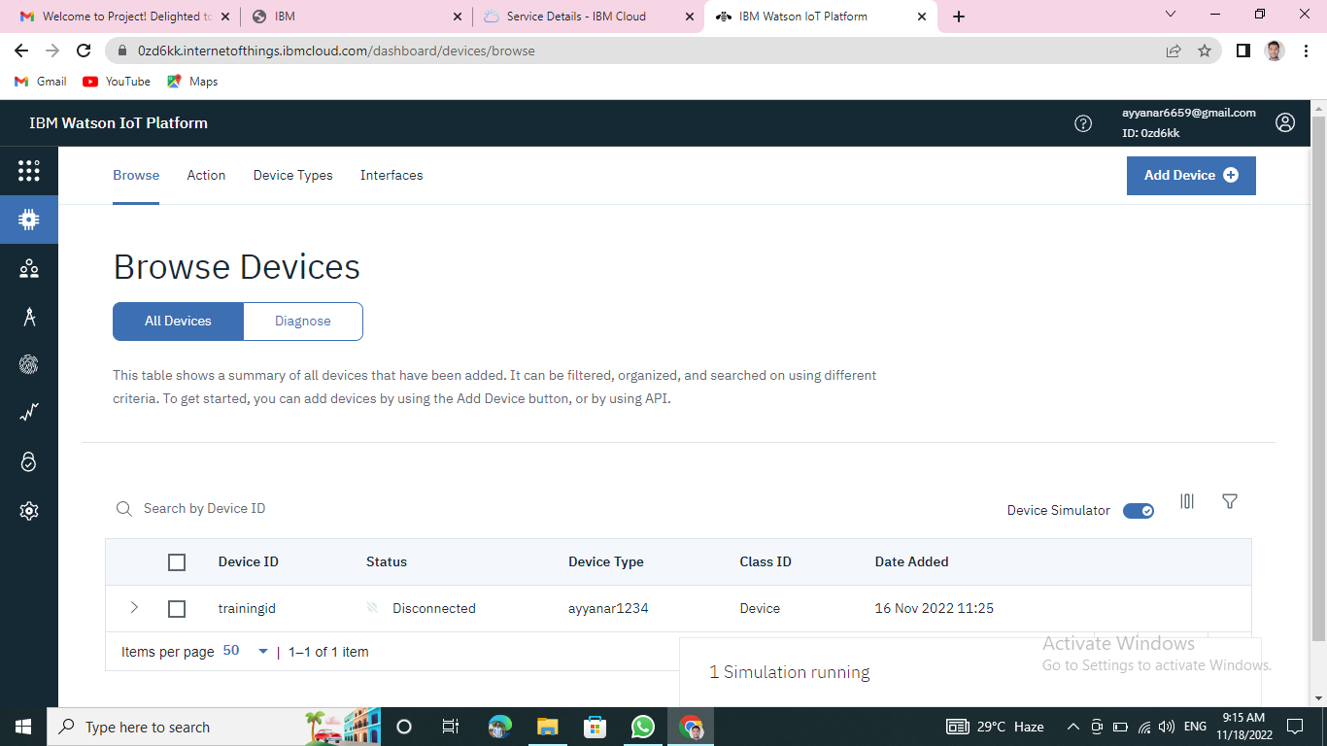

Step 4: Click on generate API keys



Step5: Click gauge from the dashboard node and fill the details

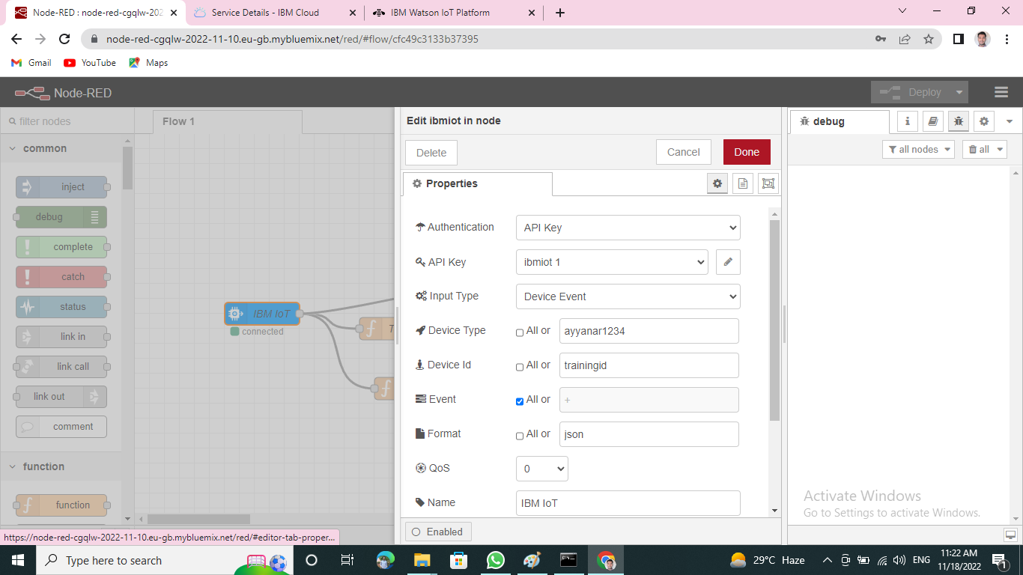

Step 6: Add functions to the gauge

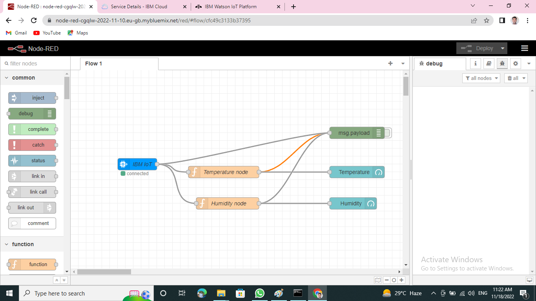

Step 7: Add another gauge and functions

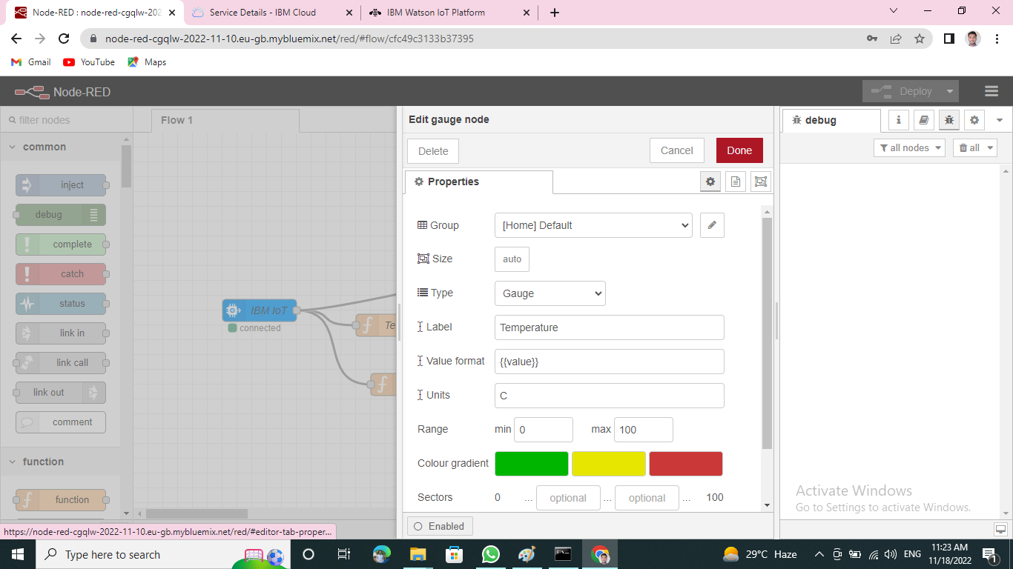

Step8: finally add alarm on and off buttons to IBM iot and debug.step

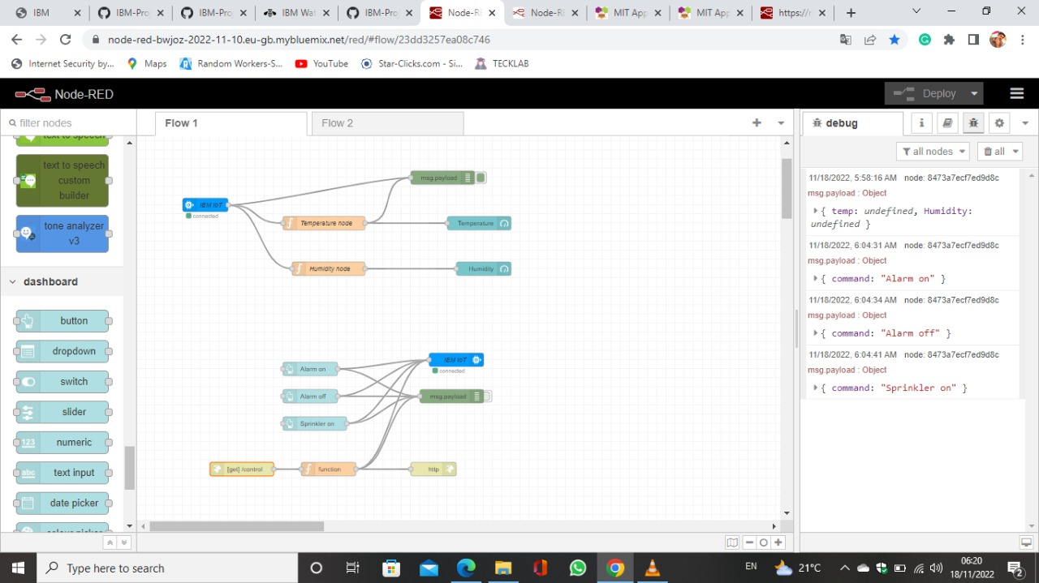

Step9: Output from node red

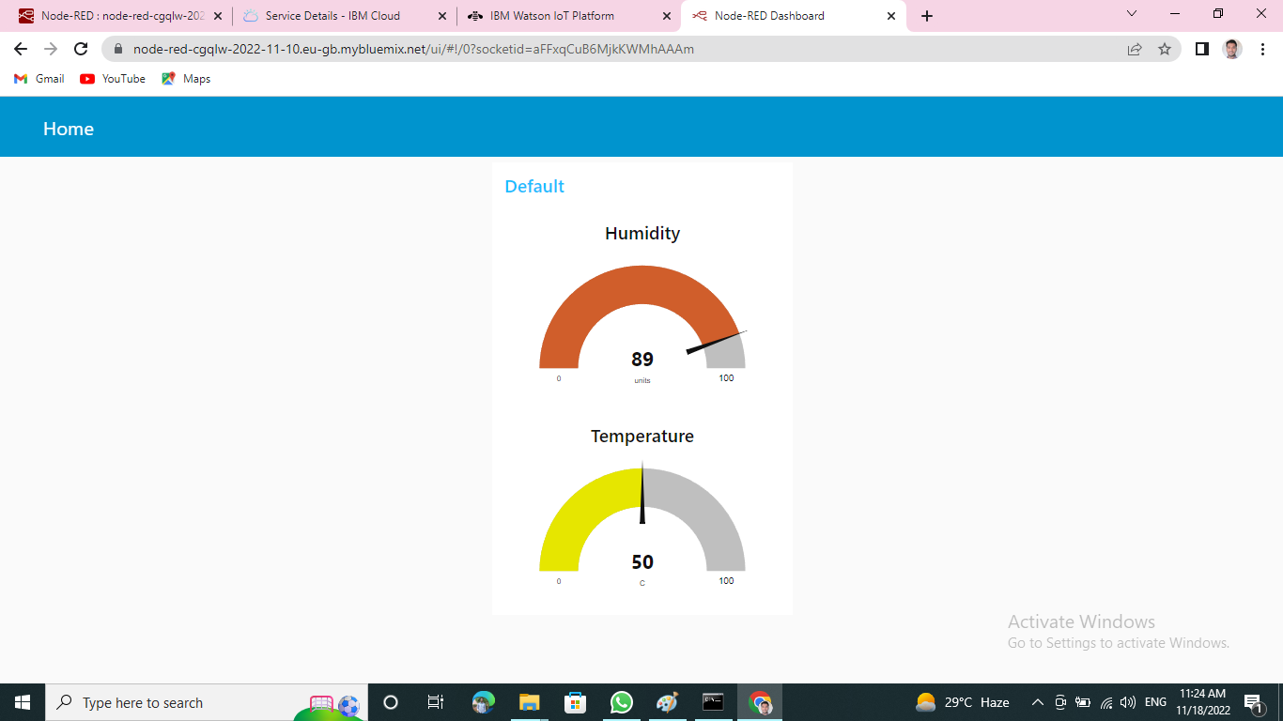

Step10: Output with light on and off button

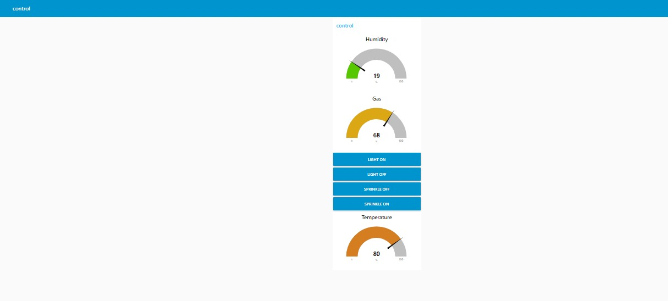

Step 11: Login to MIT app inventer and design

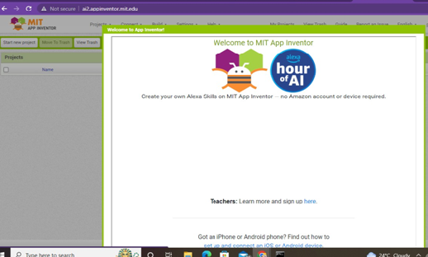

Step 12: The Output

